Kennesaw State University
Parallel and Distributed Computing
Project – MPI

Instructor: Kun Suo
Points Possible: 100
Difficulty: 

Mathematically, we know the following equation:

$$\int_{0}^{1}{\frac{4}{(1+x^{2})}dx= π}$$

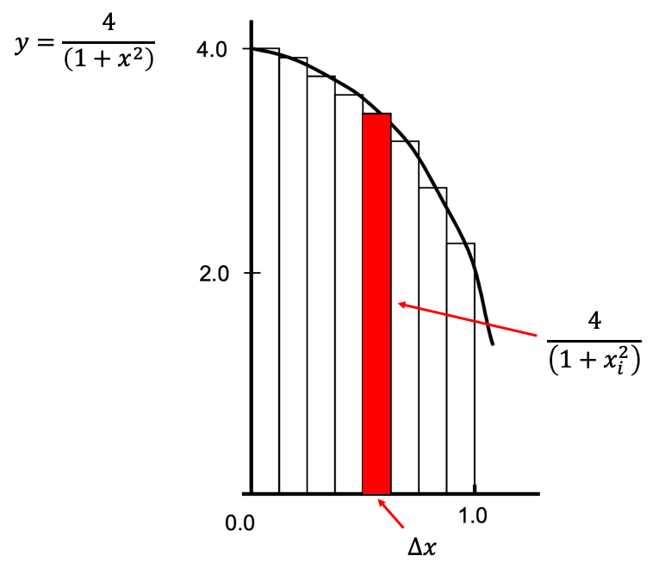

We can approximate the value of $π$ as a sum of rectangles:

$$\sum_{i=0}^{N}{f\left(x_{i}\right)Δx≈π}$$

Where each rectangle has width ∆x and height F(x_{i}) at the middle of interval i.

The following code implements the above calculation of Pi. We divide the area between 0 and 1 into 1,000,000 small rectangles and the value of PI is approximately equal to the sum of all rectangles’ size. However, the program executes in the sequential implementation.

https://github.com/kevinsuo/CS4504/blob/master/pi.c

----------------------------------------------------------------------------------------------------------------
#include <stdio.h>
#include <stdlib.h>
#include <time.h>
#define NUMSTEPS 1000000

int main() {
int i;
double x, pi, sum = 0.0;
struct timespec start, end;

clock_gettime(CLOCK_MONOTONIC, &start);
double step = 1.0/(double) NUMSTEPS;
x = 0.5 * step;

for (i=0;i<= NUMSTEPS; i++){
x+=step;
sum += 4.0/(1.0+x*x);
}
pi = step * sum;
clock_gettime(CLOCK_MONOTONIC, &end);
u_int64_t diff = 1000000000L * (end.tv_sec - start.tv_sec) + end.tv_nsec - start.tv_nsec;

printf("PI is %.20f\n",pi);
printf("elapsed time = %llu nanoseconds\n", (long long unsigned int) diff);

return 0;
}
----------------------------------------------------------------------------------------------------------------

- Write a parallel program to calculate PI using MPI based on this sequential solution.

To compile the program with MPI, use: (here file refers to your code name)
$ mpicc -g file.c -o file.o

Please write a brief report introducing your implementation.

- Estimate your MPI program execution time and compare the time using different number of threads (n=1, 2, 4, 8, …).

One possible expected output is (here my executable file is named as pi-mpi.o):

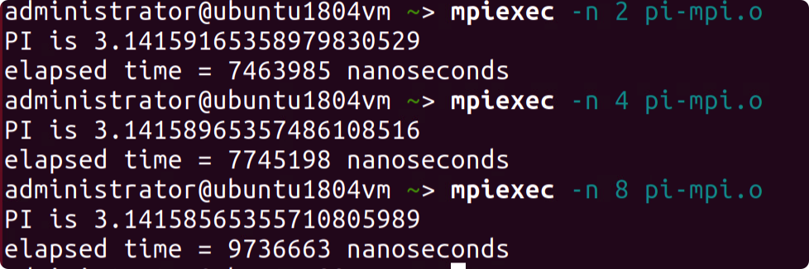

Submitting Assignment

Submit your assignment file through D2L using the appropriate link.
The submission must include the source code, and a report describe your code logic. Output screenshot of your code should be included in the report.

